# Question1:

# Working with s3 buckets

Bucket List:

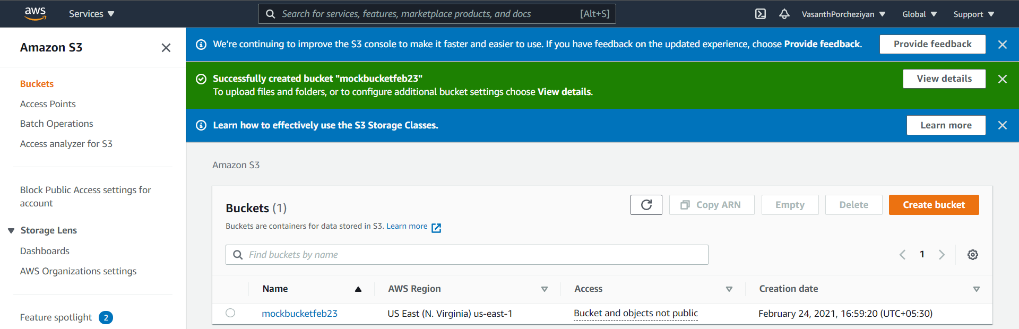

Uploaded objects:

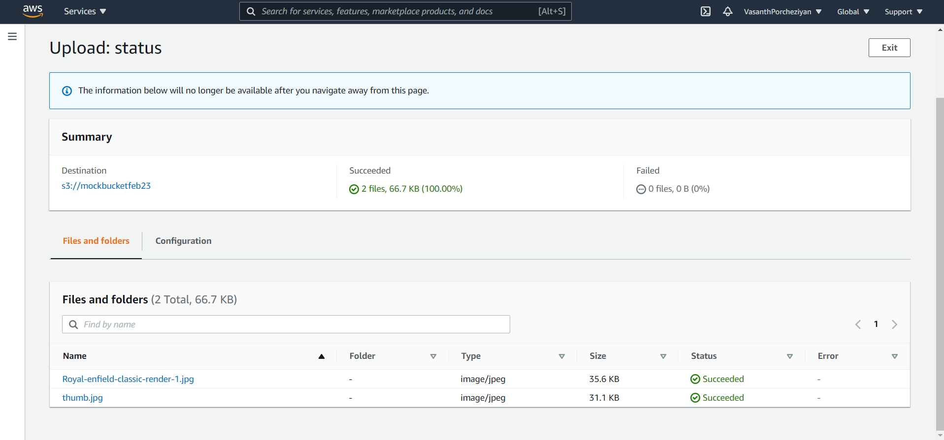

# Question 2

## Working with ec2 Instance

Instance List:

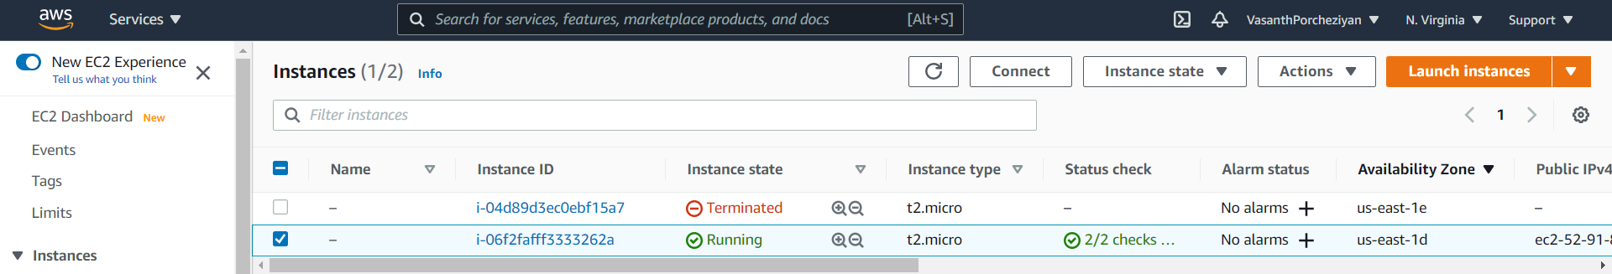

Instance detail:

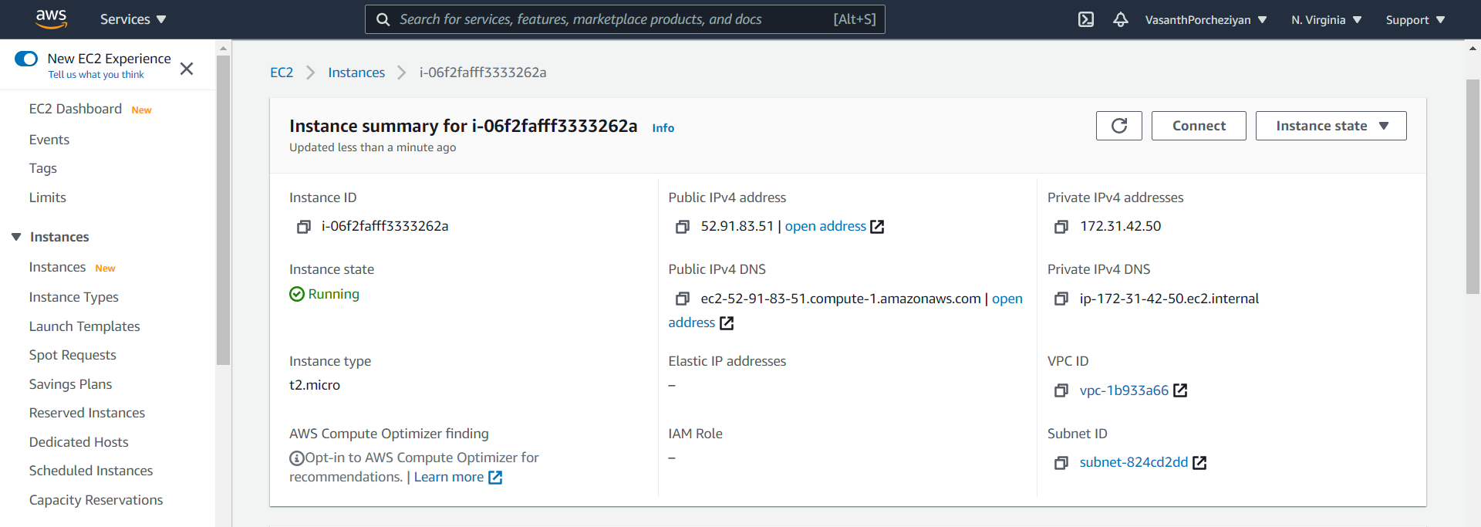

Launched screen:

